**CIS 321 PROJECT MILESTONE (1): Project Proposal & ER-Diagram**

**Project Group Number** (in Blackboard): Group (2) .

**Section Number**: Group 6

**Project Title: Airport Database**

|  |  |  |
| --- | --- | --- |
| **Leader** | **ID** | **Member Name** |
|  | 2200005672 | Abdulrhman Sami Aljuhani |
| **✅** | 2200000138 | Faisal Abduljalil Bakhurji |
|  | 2200003852 | Rakan ahmed alyaqout |
|  | 2200004948 | Majid Saleh Al-Raimi |
|  | 2200001951 | Alwaleed Ahmed Al-Qurashi |
|  | 2200000031 | Abdullah Mukhlef Alshammari |

**Instructor Name: Hussain Talal AlAttas**

**Date of Submission: 2/26/2022**

**Obtained Marks: /5**

**Project Proposal (1 mark)**

**Description** : Airlines database system flights management system where you can manage domestic and international flights and other users can book flight tickets

**Entities:**

* Airline
* Airplane
* Passenger
* Pilot
* Cabin Crew Member
* Flight
* Boarding Pass
* Ticket

**Systems Users (Actors):**

|  |  |  |
| --- | --- | --- |
|  | **User Role** | **Privileges** |
| **1** | **Admin** | **Manage flights, create and update flights** |
| **2** | **User** | **Book flight tickets and view the flights** |

**ER-Diagram (4 marks)**

**System Requirements & Relationship between entities:**

**Airlines database system flights is organized into:**

**Flights** are the main entity that most other entities are related to it. Each flight belongs to an **airline**. Each flight gets piloted by a **pilot.** Each flight has many **crew members.** Each flight has many passengers and boarding passes. **Boarding passes** are printed and derived from **tickets.** Each entity has its own suitable attributes such as, destination, origin, entity IDs, names.

**ER Diagram:**

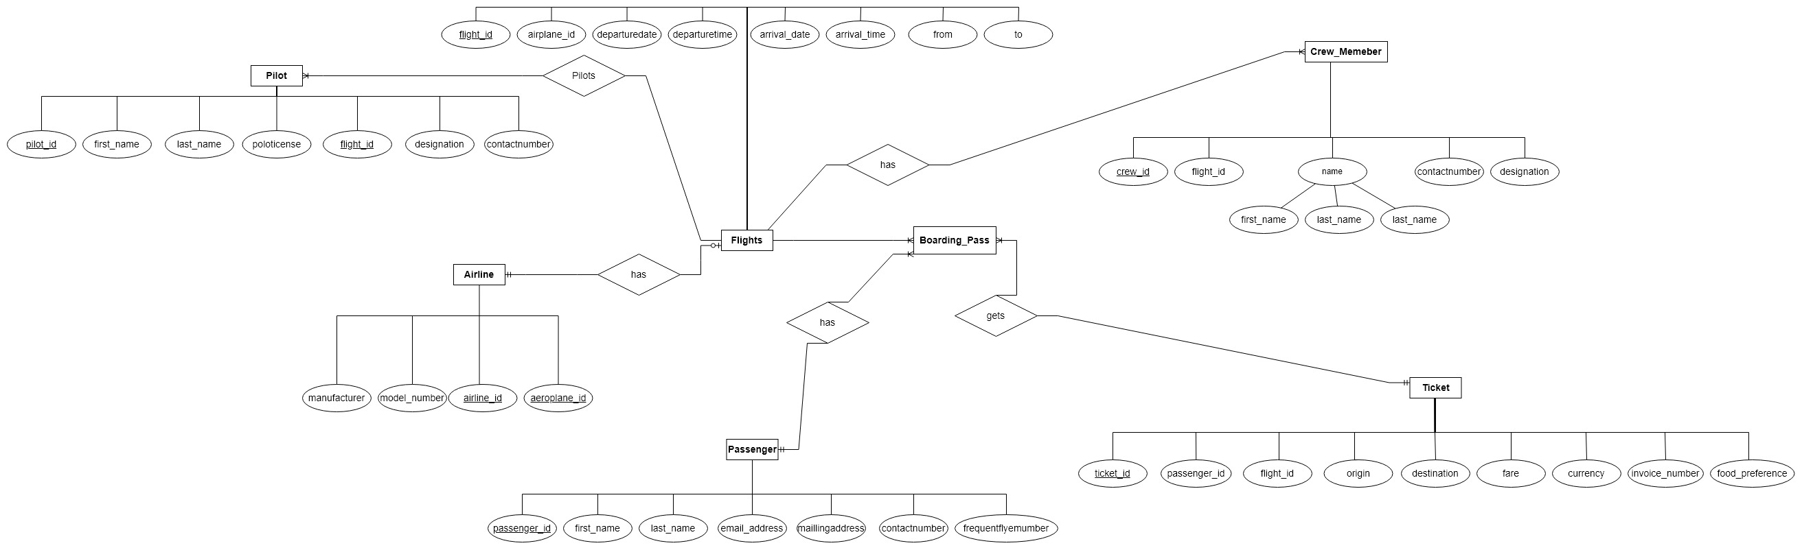

**Instructor(s) Approval**: Approved Not Approved *(needs to be changed)*

**Feedback Comments:**